Campus2Corp: Assignment 1

# Problem Statement

Given the historical stock prices for 1 year in the csv format.

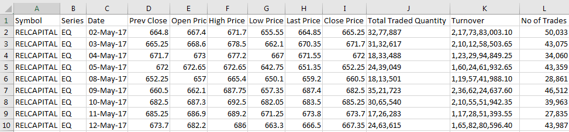

Write OOP based solution to:

1. Calculate Average (Arithmetic mean) of Close Prices for each Symbol.
2. For each symbol, find the Date for which Close Price was highest.